
Integrating Faith in Coaching Leadership and Organisations
Are you offering your coaching and mentoring skills to others?

Have you been mentoring colleagues at work or coaching a team member, or in a pastoral role in church?

Are you keen to develop your skills more and become a professionally accredited coach or mentor? Is your Christian faith integral to how you practice?

Have you felt that as a Christian coach or mentor, there is not a pathway to integrate your faith in practice and become professionally accredited?

If so, this NEW Course is for you.

Forward Partnership

Forward Partnership will run Christian Coaching and Mentoring with EMCC accreditation, in association with Queen’s Foundation College Birmingham.

September 2025 - July 2026

Residentials 24 - 26 Oct 2025 and 12 - 14 June 2026. Online learning at regular intervals.

As you explore and learn the creative and practical art of coaching and mentoring, your EMCC portfolio is developed throughout the course, culminating in accreditation with EMCC at Senior Practitioner level. *

You will:
- Have the support of a Coach Practice Mentor throughout your learning journey.
- Work with other participants to practice and develop your skills.
- Participate in two immersive residential weekends to learn theory and apply this in practice.
- Participate in further on-line learning and practice sessions throughout the course.

The tutor team are all EMCC Accredited Senior Practitioner Coaches or Mentors who are working as Christian practitioners, all of whom have developed their own integrative practice.

This exciting Christian coaching and mentoring course is designed with experiential components in both delivering coaching and mentoring and in receiving individual mentoring to support your learning journey.

The three main elements of this course are:

- The underpinning theories of coaching and mentoring, including listening theories, presence, psychological and theological perspectives.

- Personal development, including supervision, self-awareness, emotional understanding and self-care.

- Coaching and mentoring tools and how these translate into a faith environment.

The course includes learning by working in small groups and 1:1 in order to enhance and draw coaching and mentoring skills together in a warm, supportive environment. We look forward to meeting you!

Fees £3,500 includes tuition and mentor support, residential costs, and EMCC accreditation fees for 5 years.

*This is subject to several elements, including full course attendance, completion of the written work, developing mentoring and coaching hours and joint assessment with the individual mentor and course leaders. All participants will be supported to gain accreditation wherever possible.

For an application pack contact sue@forwardpartnership.org.uk

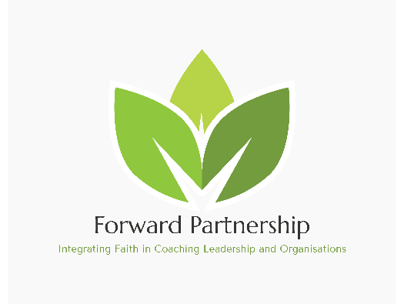


Forward Partnership Ltd, holds the Global Quality Award Conferred by the EMCC for this course.

