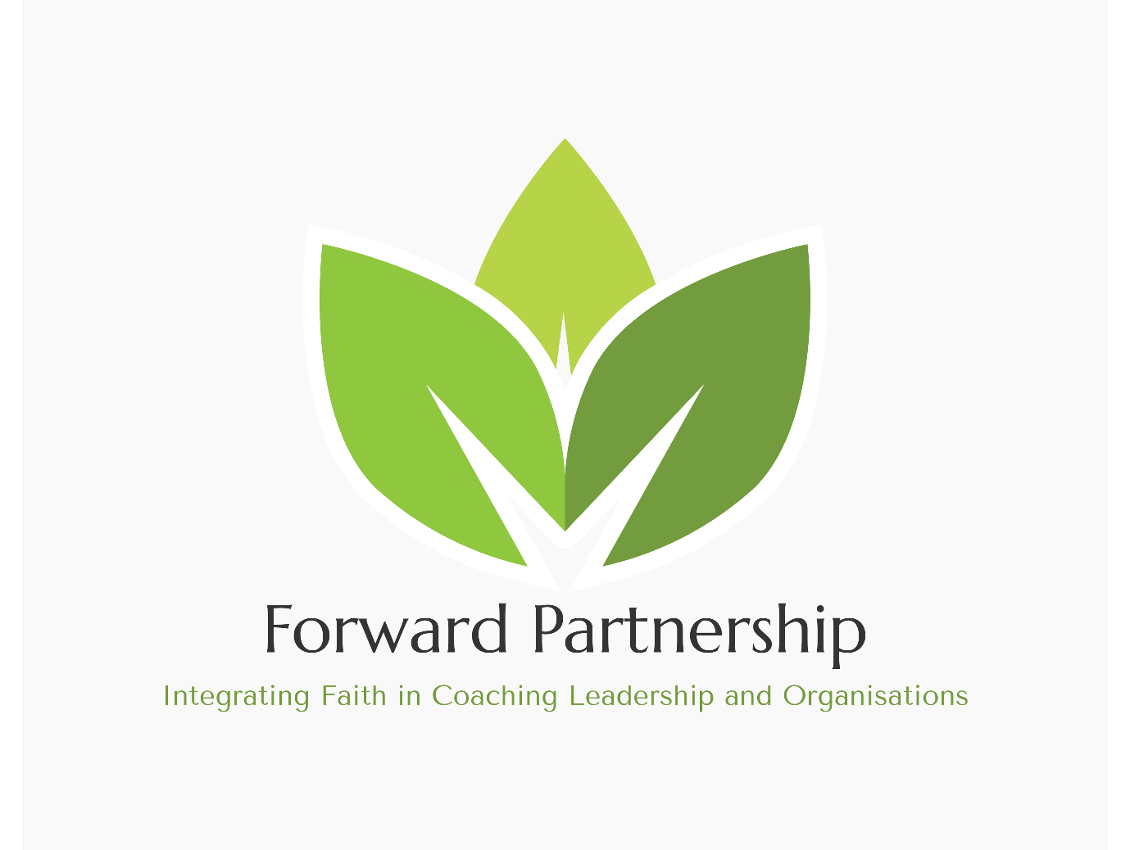

Forward Partnership Ltd customer privacy notice
This privacy notice tells you what to expect us to do with your personal information.
- Contact details
- What information we collect, use, and why
- Lawful bases and data protection rights
- Where we get personal information from
- How long we keep information
- Who we share information with
- How to complain

Contact details

Email
admin@forwardpartnership.org.uk

What information we collect, use, and why
We collect or use the following information to course recruitment and teaching:
- Names and contact details for students
- Gender
- Date of birth
- Dietary requirements (including vegetarian, vegan, gluten free and halal requirements)
- Health information (including conditions and allergies)
- Special Educational Needs and Disabilities (SEND) or additional support information (includes reasonable adjustments and special educational needs and disabilities)
- Exam results and qualifications
- Character reference
We collect or use the following information for:
- Establishing the previous experience and eligibility for applicants to commence the course
- Providing Queen’s Foundation with details required for meeting the needs of participants during the residential elements
- To comply with the requirements of the EMCC we share email contact details to enable our participants access the accreditation process of EMCC

Lawful bases and data protection rights
Under UK data protection law, we must have a “lawful basis” for collecting and using your personal information. There is a list of possible lawful bases in the UK GDPR. You can find out more about lawful bases on the ICO’s website.
Which lawful basis we rely on may affect your data protection rights which are in brief set out below. You can find out more about your data protection rights and the exemptions which may apply on the ICO’s website:
- Your right of access - You have the right to ask us for copies of your personal information. You can request other information such as details about where we get personal information from and who we share personal information with. There are some exemptions which means you may not receive all the information you ask for. You can read more about this right here.
- Your right to rectification - You have the right to ask us to correct or delete personal information you think is inaccurate or incomplete. You can read more about this right here.
- Your right to erasure - You have the right to ask us to delete your personal information. You can read more about this right here.
- Your right to restriction of processing - You have the right to ask us to limit how we can use your personal information. You can read more about this right here.
- Your right to object to processing - You have the right to object to the processing of your personal data. You can read more about this right here.
- Your right to data portability - You have the right to ask that we transfer the personal information you gave us to another organisation, or to you. You can read more about this right here.
- Your right to withdraw consent – When we use consent as our lawful basis you have the right to withdraw your consent at any time. You can read more about this right here.
If you make a request, we must respond to you without undue delay and in any event within one month.
To make a data protection rights request, please contact us using the contact details at the top of this privacy notice.

Our lawful bases for the collection and use of your data
Our lawful bases for collecting or using personal information course recruitment and teaching are:
- Consent - we have permission from you after we gave you all the relevant information. All of your data protection rights may apply, except the right to object. To be clear, you do have the right to withdraw your consent at any time.
- Contract - we have to collect or use the information so we can enter into or carry out a contract with you. All of your data protection rights may apply except the right to object.
- Legitimate interests – we’re collecting or using your information because it benefits you, our organisation or someone else, without causing an undue risk of harm to anyone. All of your data protection rights may apply, except the right to portability. Our legitimate interests are:
  - For processing information relating to the course assignments. This is necessary for a participant to pass the course. For processing information relating to becoming a professionally accredited Coach\/Mentor
- Vital interests - collecting or using the information is needed when someone’s physical or mental health or wellbeing is at urgent or serious risk. This includes an urgent need for life sustaining food, water, clothing or shelter. All of your data protection rights may apply, except the right to object and the right to portability.
Our lawful bases for collecting or using personal information to provide assessment and accreditation are:
- Contract – we have to collect or use the information so we can enter into or carry out the contract with you stated above. All of your data protection rights may apply except the right to object.
- Legitimate interests – we’re collecting or using your information because it benefits you, our organisation or someone else, without causing an undue risk of harm to anyone. All of your data protection rights may apply, except the right to portability. Our legitimate interests are:
- Sharing information amongst the course trainers and leaders in order to benefit your progression on the course.
- Sharing information with EMCC, outlined further below.

Where we get personal information from
- Directly from you

How long we keep information
We will keep this information for a period of 5 years to comply with EMCC requirements for EQA Courses.

Who we share information with

Joint controllers
We have a joint controller relationship with EMCC UK. We process your personal information with that joint controller for the following reason: Sharing information with the EMCC is necessary to obtain professional accreditation..

Others we share personal information with
- Other relevant third parties:
    - The European Mentoring and Coaching Council (EMCC) UK

How to complain
If you have any concerns about our use of your personal data, you can make a complaint to us using the contact details at the top of this privacy notice.
If you remain unhappy with how we’ve used your data after raising a complaint with us, you can also complain to the ICO.
The ICO’s address:
Information Commissioner’s Office
Wycliffe House
Water Lane
Wilmslow
Cheshire
SK9 5AF
Helpline number: 0303 123 1113
Website: https://www.ico.org.uk/make-a-complaint

Last updated 30 May 2025

